SD Small Engraver

Model 3025S CNC Engraver:
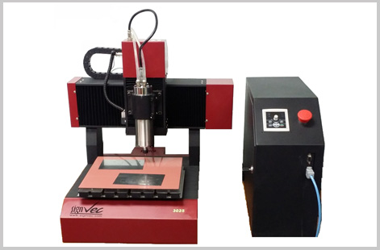
· Integral cast-iron frame
· Rolling ball screw from Germany
· Configured with 800W inverter-driven spindle motor cooled by water
· Y axis configured with imported linear square rail

Application:
Advertising, seals processing, hand crafts, special instrument processing, little moulds processing etc.

Characteristics:
Good at processing small precision instruments, multi-file speed control, speed curve and a straight line independent control; high-speed data transmission; higher power, process metal material in high efficiency.

Processed products:
Stainless steel chest-brand, copper seals, jade seals, making on the working piece, copper electrodes, punching moulds and thermos

Model 3025V CNC Milling & Engraving machine:

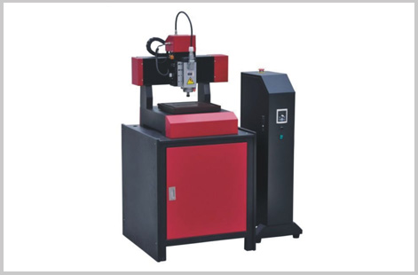

· Integral cast-iron frame
· Rolling ball screw from Germany
· 1500W inverter-driven spindle motor
· X, Y, Z all axis configured with imported linear square rail

Features:
Good at processing small precision instruments, working without computer, Standard configured with 4G inner memory capacity, support USB transmitting files, can save massive processing files. Power off restoring, breaking

Common Features

Model | 3025S | 3025V
Working Size | 300x250x40mm | 300x250x60mm
Spindle Motor | 800W | 1500W
Motion Speed | 0~6000 mm/min
Spindle Speed | 6000~24000 RPM
Engraving Tools | ø3.175mm, ø4, ø6mm (optional)
Dictate Format | HPGL | G Code
Transmitting Parts | Rolling ball screw from germany
Resolution | 0.01mm

- Dust Collecting System (optional)
- Vacuum System (optional)
- Servo System (optional)
- USB transmitting directly (optional)
- THK linear rail from Japan (optional)
- Notes: Any changes of technical parameters without notice

