Universal Laser System - PLS Series

PROFESSIONAL – PLS SERIES:

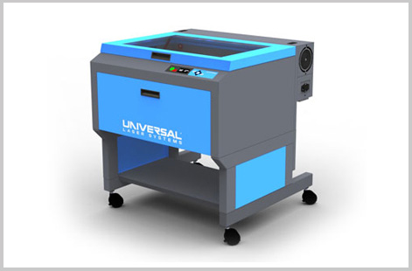
Universal’s Professional Series of CO2 laser systems provide an unbeatable combination of high power (up to 150 watts using dual lasers), three platform sizes and an advanced, materials-based print driver that delivers consistently excellent cutting and engraving results. The Professional Series is ideal for high speed cutting jobs; deep high-throughput engraving; and fast, permanent marking.
System Specifications:
 | PLS4.75 | PLS6.75 |  | PLS6.150D
Work Area | 24" x 18" (610 x 457mm) | 32" x 18" (813 x 457mm) |  | 32" x 18" (813 x 457mm)
Maximum Part Size | 29" x 23" x 9" | 37" x 23" x 9" |  | 37" x 23" x 9"
 | (737 x 584 x 229mm) | (940 x 584 x 229mm) |  | (940 x 584 x 229mm)
Dimensions | 36" x 39" x 36" | 44" x 39" x 36" |  | 44" x 39" x 36"
 | (914 x 991 x 914mm) | (1118 x 991 x 914mm) |  | (1118 x 991 x 914mm)
Rotary Capacity | Max Diameter 8" (203mm)
Motorized Z Axis Lifting Capacity | 40 lbs (18 kg)
Available Focus Lenses | 1.5" (38mm) 2.0" (51mm) *standard 2.5" (64mm) 4.0" (102mm)
Laser Platform Interface Panel | Keypad and LCD display shows current file name,
 | laser power, engraving speed, PPI and run time
Operating System Compatibility | Requires a dedicated PC to operate.
 | Compatible with Windows XP/Vista/7 - 32/64 bit.
PC Connection | USB 2.0
Cabinet Style | Floor-Standing
Optics Protection | Air Assist Optional
Laser Options | 10, 25, 30, 40, 50, 60, 75 Watts |  |  |  | 10, 25, 30, 40, 50, 60, 75 Watts
 |  |  |  |  | Equipped for dual lasers
Approximate Weight | 270 lbs (122kg) |  | 325 lbs (147kg) |  | 345 lbs (156kg)
Power Requirements | 110V/10A; 220V-240V/5A |  |  |  | 220V-240V/15A
Exhaust Connection | One 4" (102 mm) port |  | Two 4" (102 mm) ports
 | 250 CFM @ 6" static pressure |  | 500 CFM @ 6" static pressure
 | (425 m³/hr at 1.5 kPa) |  | (850 m³/hr at 1.5 kPa)

