Universal Laser System - ILS Series
INDUSTRIAL – ILS SERIES:
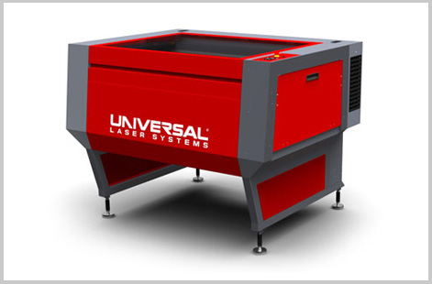
The Industrial Laser Series can grow with you now and in the future to meet your changing production needs. Being able to custom-configure your laser system is a ULS core philosophy. We believe you should purchase only those options you actually need. Should your needs change, you can easily expand the capabilities of your ILS laser system at any time with our optional accessories.
For example, suppose you start out with an ILS9.150D equipped with a 30-watt laser. As your production needs increase, you can upgrade to a higher-power laser for faster throughput. Then when more demanding jobs start coming in, you can mount a second ULS laser for faster cutting and deeper engraving. You can convert your ILS from a light-duty to heavy-duty system in the field quickly and easily. The Industrial Laser Series offers unmatched upgradeability.
System Specifications:
 | ILS9.75 or ILS9.150D | ILS12.75 or ILS12.150D
Work Area | 36" x 24" (914 x 610mm) | 48" x 24" (1219 x 610mm)
Maximum Part Size | 40.5" x 30" x 12" (1029 x 762 x 305mm) | 52.5" x 30" x 12" (1334 x 762 x 305mm)
Dimensions | 57" x 44" x 46" (1448 x 1118 x 1168 mm) | 69" x 44" x 46" (1753 x 1118 x 1168 mm)
Rotary Capacity | Max Diameter 10.25" (260mm)
Motorized Z Axis Lifting Capacity | 60 lbs (27 kg)
Pass-Through Class 4 Mode | 20" x ∞" (508 x ∞mm)
Accessible Work Area
Pass-Through Class 4 Mode Clearance | 23.75" x 8" (603 x 203mm)
Available Focus Lenses | 2.0" (51mm) *standard 3.0" (76mm)
Laser Platform Interface Panel | Keypad and LCD display shows current file name,
 | laser power, engraving speed, PPI and run time.
Operating System Compatibility | Requires a dedicated PC to operate.
 | Compatible with Windows XP/Vista/7 32/64 bit.
PC Connection | USB 2.0
Cabinet Style | Floor-Standing
Optics Protection | Plumbed for compressed-air-based optics protection
Laser Options | 10, 25, 30, 40, 50, 60, 75 Watts. Dual Laser Configuration Optional
Approximate Weight | 400 lbs (181 kg) | 430 lbs (195 kg)
Power Requirements | 220V-240V/10A (1 laser) 220-240V/16A (2 lasers)
Exhaust Connection | Two 4" (102 mm) ports 700 CFM @ 6" | Two 4" (102 mm) ports 1000 CFM @ 6"
 | static pressure (1190 m³/hr at 1.5 kPa) | static pressure (1700 m³/hr at 1.5 kPa)

